1. **Creating and Renaming Files/Directories**
   1. Create a directory named test_dir using mkdir.
   2. Inside test_dir, create an empty file called example.txt.
   3. Rename example.txt to renamed_example.txt using mv

**Answer-**

Explanation:

* **mkdir** creates a new directory.
* **touch** creates an empty file.
* **mv** renames example.txt to renamed_example.txt.

1. **Viewing File Contents**

2.1 Use cat to display the contents of /etc/passwd.

2.2 Display only the first 5 lines of /etc/passwd using head.

2.3 Display only the last 5 lines of /etc/passwd using tail.

**Answer-**

2.1

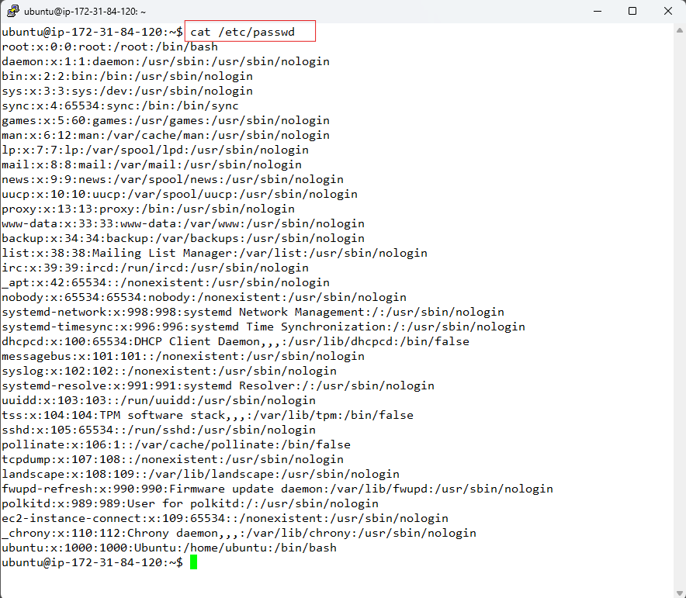

Explanation:

* cat prints full file content.

2.2 & 2.3

Explanation:

* head -n and tail -n show top and bottom lines respectively.

1. **Searching for Patterns**

3.1 Use grep to find all lines containing the word "root" in /etc/passwd.

**Answer-**

Explanation:

* grep filters lines that contain the word "root" from /etc/passwd.

1. **Zipping and Unzipping**

4.1 Compress the test_dir directory into a file named test_dir.zip using zip.

4.2 Unzip test_dir.zip into a new directory named unzipped_dir.

**Answer-**

Explanation:

* **zip -r** recursively zips a directory.
* **unzip -d** extracts into a specified folder.

**5. Downloading Files**

* 1. Use wget to download a file from a URL (e.g., <https://example.com/sample.txt>).

**Answer-**

Explanation:

* **wget** is used to download files from the web using URL.

**6. Changing Permissions**

6.1 Create a file named secure.txt and change its permissions to read-only for everyone using chmod.

**Answer-**

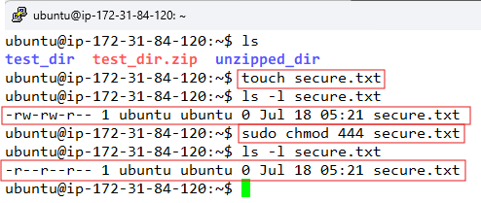

Explanation:

* **chmod 444** = read-only (r--r--r--).
* **ls -l** confirms permissions.

7. **Working with Environment Variables**

7.1 Use export to set a new environment variable called MY_VAR with the value "Hello, Linux!".

**Answer-**

Explanation:

* **export** to sets a shell variable.
* **echo $VAR** shows its value.